Louisiana Tech University Clinical Lesson Plan Template
Author(s): Bruce R. Magee |  |  | Date Written: October 15, 2018
School: NA |  | Grade: 11 | Subject: English
Lesson Topic: Samuel Clemens letter to his sister, March 9-11, 1859 |  | Date Taught: January 25, 2019 | Time Frame: 50 minutes
Demographic Data
Number of Students: NA |  | Gender: NA | IEP/504: NA
Race/Ethnicity: NA |  |  | Language(s): NA
Lesson Foundations
- Content Knowledge Connections
Assessment Data (formative/summative assessments, observations, etc.) | - NA.  - I’m planning the lesson with the assumption that most of the students can read, but not all at the same level.
Prerequisite Learner Knowledge/Skills | - They need to be able to read and write.  - They need basic research skills.  I’d like them to have general knowledge about  - Letters  - Sam Clemens  - Mardi Gras
Learner interests, needs, etc., to inform selection of learning outcomes and differentiation | - Louisiana children have a natural interest in our state’s culture, especially Mardi Gras.
Describe how this lesson fits within a unit or sequence of lessons | - This is the first lesson of five. It will introduce the letter of Sam Clemens to his sister, Pamela Moffett.
Personal research on lesson topic | - The Mark Twain Project.  - Louisiana History courses in 8th grade and college.  - I’m the co-editor of the Louisiana Anthology website, and have edited numerous works related to Mardi Gras.  - I’m also the co-host of the Louisiana Anthology Podcast, and have interviewed several scholars about various Mardi Gras traditions.
- Learning Outcomes and Formal Measurable Objectives
Learning Outcome | Measurable Objective
List | TLW list three cities in Louisiana (besides New Orleans) that have Mardi Gras parades.
Apply | TLW apply the informal letter model to their Mardi Gras letter.
Analyze | TLW analyze another student’s essay and give feedback.
- Standards Directly Connected to the Lesson (alphanumeric AND text)
ELA 11 RSL 3. Analyze the impact of the author’s choices regarding how to develop and relate elements of a story or drama, including how the author develops character and setting, builds the plot and subplots, creates themes, and develops mood/atmosphere.
ELA 11 RSL 4. Determine the meaning of words and phrases as they are used in the text, including figurative and connotative meanings; analyze the impact of specific word choices on meaning and tone, including words with multiple meanings or language that is particularly fresh, engaging, or beautiful. (Include Shakespeare as well as other authors.)
ELA 11 SLS 1.b. Work with peers to promote civil, democratic discussions and decision-making, set clear goals and deadlines, and establish individual roles as needed.
ELA 11 LS 1. Demonstrate command of the conventions of Standard English grammar and usage when writing or speaking.
ELA 11 LS 2. Demonstrate command of the conventions of Standard English capitalization, punctuation, and spelling when writing.
- Assessment
- Bellringer (5 points)
- Notetaking (15 points)
- Journaling (5 point)
- Group work (5 point)
- Exit ticket (3 points)

- Classroom Preparation
Classroom & Class Organization (seating, grouping, etc.) | - The class will work as individuals and in groups.
Teacher/Student Materials | - Handouts (attached)  - Bellringer  - Guided note taking  - Journaling  - Group Work  - Exit Ticket
Technology Resources | - Computer  - Internet Connection  - Browser  - Powerpoint  - Projector  - Screen  - Speaker
Management Plan (behavior, time, etc.) | - Classroom timer  - Listen and follow directions.  - Raise your hand before speaking or leaving your seat.  - Keep your hands and feet to yourself.  - Respect your classmates and your teacher.

Pedagogy
- Lesson Introduction
- Bellringer: Write the names of 3 cities in Louisiana (besides New Orleans) that have Mardi Gras parades. (5 minutes. 3 points).

- Teaching Strategies
- Integrate technology into the lesson.
- Include popular culture
- Make time for journaling.
- Have students work in groups.

- Modifications/Accommodations
- Make sure the groups have students with different levels of abilities.

- Learning Activities
- Bellringer (5 minutes, 3 points).
- Mini-lecture & note-taking on the parts of an informal letter (10 minutes, 5 points).
- Drafting on your Mardi Gras letter (15 minutes, 5 points).
- Partner work — peer evaluation of letters (15 minutes, 5 points).
- Exit ticket (5 minutes, 3 points).
- Closure
- Exit ticket. 3-2-1 ticket for the week.

Required Lesson Plan Reflection (See Pre-Conference form). Required Teaching Reflection (See Post-Conference form).

Sam Clemens’ Letter to Pamela Moffet

Bellringer: Write the names of 3 cities in Louisiana (besides New Orleans) that have Mardi Gras parades. (5 minutes. 3 points).

Mini-lecture & notetaking on the format for an informal letter.
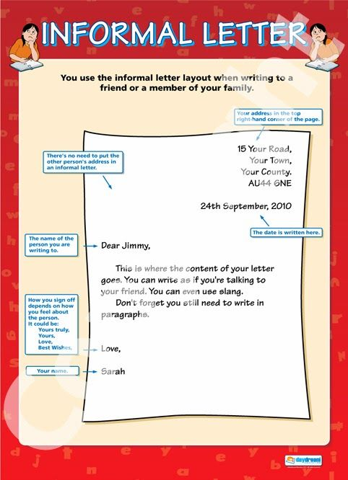

Note-taking (10 minutes, 5 points):
Label the parts of an informal letter here, and follow them when you complete your Mardi Gras letter.

Drafting: Continue to work on your Mardi Gras rough draft. (15 minutes 5 points)

Partner work: Peer review. (15 minutes 5 points) Get with your elbow partner. Read each other’s rough draft, and give them feedback on how to improve it for the final draft on Monday.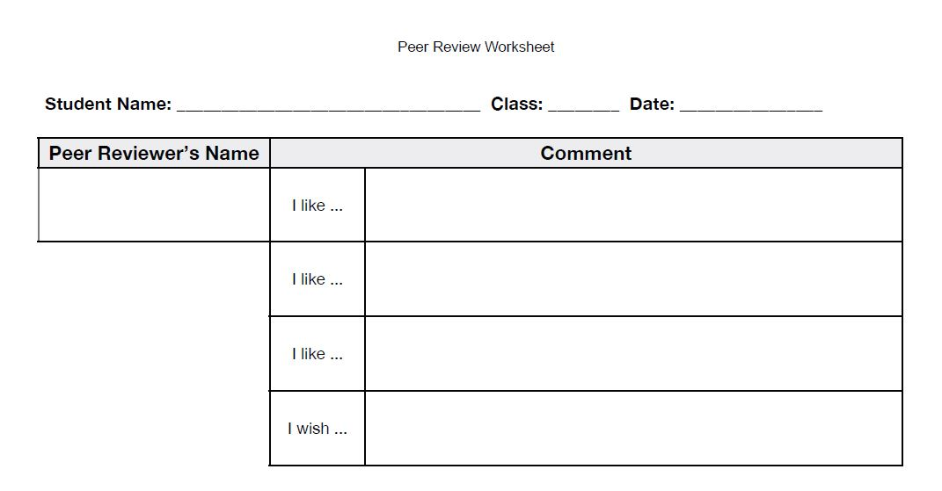

Exit ticket (5 minutes. 3 points): Include the whole week.
