Unit Overview:
- Describe the scope of content which will be included in the unit: explain how you determined what specific standards and content (topics) to bundle into a unit of instruction. List the standards covered in the unit.

The unit will cover several myths from Native American tribes in Louisiana. We chose these myths to give students context on the creative history of what is now Louisiana before it was a part of the United States. The goals of this unit are:
- To increase students’ understanding of Native American mythology.
- To help the students learn to extract cultural values from various myths.
Standards used:
ELA 11 RSIT 1. Cite strong, thorough, and relevant textual evidence to support analysis of what the text says explicitly as well as inferences drawn from the text, including determining where the text leaves matters uncertain.
ELA 11 RSIT 3. Analyze a complex set of ideas or sequence of events and explain how specific individuals, ideas, or events interact and develop over the course of the text.
ELA 11 SLS 1.b. Work with peers to promote civil, democratic discussions and decision-making, set clear goals and deadlines, and establish individual roles as needed.
ELA 11 LS 1. Demonstrate command of the conventions of Standard English grammar and usage when writing or speaking.
ELA 11 LS 2. Demonstrate command of the conventions of Standard English capitalization, punctuation, and spelling when writing.

- Explain how the unit fits within the overall curriculum including an explanation of precedents and antecedents (what comes before and after). Also, describe the prerequisite skills students will need in order to be successful in this unit.

At the end of the Native American Myths unit, we plan to have the students engage in a Socratic seminar to discuss the myths we read and what they can tell us about the indigenous cultures of Louisiana.
Students will need basic reading and writing skills as well as the ability to work civilly in a group.

- Describe how the unit of instruction will be meaningful to learners.
  - How does the unit meet both academic and social needs of the learners?
  - How does the unit meet both current and future needs of the learners?

This unit will provide a basis for students to begin learning Louisiana literature, which will offer a connection for them to their broader community. They will also learn to appreciate indigenous contributions to the state’s literary work and have an awareness of Louisiana’s first inhabitants and their cultures.
Am

  - Identify areas of possible student misconceptions and explain how these will be addressed within the unit.

Students may assume that all mythology is the same and expect to hear Greek myths/Bible stories with different names for gods/heroes. Instead, they will find differences not only from other mythologies, but also among the different native tribes.

  - How does the unit connect content knowledge with authentic, real world contexts and applications?
This unit connects directly with communities still extant in Louisiana, as well as Louisiana literature in a broader sense. Students will learn more about their state, and about the various cultures within it.

  - How does the unit integrate content across subject silos?

This unit discusses Louisiana history, different religions, and cultural values both in Louisiana, and around the world.
I
Lesson Sequence:
- Show the planned sequence of topics, lessons, activities, and assessments within the unit.
  - Use an outline or graphic format to show an overall picture of the unit.
    - For elementary unit plans clearly show the interconnectedness of lessons from the core disciplines of ELA, math, science, and social studies. Additionally, show the connections with arts and physical education.
    - For secondary {6-12) unit plans clearly show cross-curricular connections: especially, integration of reading and language across disciplines. Additionally, show specific connections
to post-secondary education, and careers.

      - Monday. Introduction to the topic of Native American myths, reading of the Choctaw “How Snakes Acquired Their Poison” and the Chitimacha “Creation” and “The Gifts of the Sky-God”. Students will participate in guided notetaking and try to come up with their own “origin” myths.
      - Tuesday.
      - Wednesday.
      - Thursday. Students will be given a brief overview of the Greek and biblical creation stories, the biblical stories of the Fall of Man and the Tower of Babel, and the Greek story of Bellerophon. Afterward, they will, in guided notetaking and group discussion, compare and contrast these myths with the Native American ones and discuss the different values of indigenous, Greek, and ancient Abrahamic cultures.
      - Friday. We will have a Socratic seminar for students to discuss the various myths we’ve read over the week as a group. They will be responding to a series of questions on the stories discussed.

Unit Launch:
- How will you engage students with the unit?
  - How will you engender excitement, anticipation, enthusiasm, and curiosity?
  - How will you motivate students to succeed at high levels?
C. How will you communicate high expectations?
- How will you present the "Unit Overview" and "Lesson Sequence" to students?
- How will you inform the school, community, and parents/guardians about the unit?
  - Include in your unit a press release, a memo to your principal and other teachers, and a letter to parents about your unit. In each of the aforementioned communications be sure to
explain how the particular constituents can contribute to the unit.

  - Include in your unit a press release, a memo to your principal and other teachers, and a letter to parents about your unit. In each of the aforementioned communications be sure to
explain how the particular constituents can contribute to the unit.

On Monday, I will begin the unit by asking students to come up with a story to explain a natural phenomenon, without relying on scientific explanations. Then, I will explain that we will be discussing the mythology of the native tribes of Louisiana. I believe the students will find the initial bell-ringer engaging and it will be a good hook to capture their attention for the unit.

Socratic Seminar Grading Rubric

A. PARTICIPATION
A. Student spoke several times throughout the discussion, offered thoughtful, relevant commentary, and was civil to their peers.
B. Student spoke up a couple of times during the discussion and was civil to their peers.
C. Student did not speak much during the discussion or parroted other’s thoughts and did not listen to/was neglectful toward their peers.
D. Student did not offer any commentary during the discussion and was rude to their peers.

B. PARAGRAPH DEVELOPMENT
A. Paragraph flows smoothly; it has a clear topic sentence and sufficient support to follow with clean, logical organization.
B. Paragraph mostly flows smoothly with only a couple awkward points; it has a clear topic sentence, and support is generally organized logically.
C. Paragraph is a bit awkward but still makes sense overall; organization is somewhat messy.
D. Paragraph the flow is very awkward/confusing; the topic sentence is unclear, and organization is illogical.

C. TEXTUAL SUPPORT
A. Student provides ample textual support, citing several specific examples from one or more of the myths discussed.
B. Student provides good textual support, citing at least one specific example from the myths discussed.
C. Student provides decent textual support, referencing one or more of the myths discussed but never citing a specific example.
D. Student provides poor textual support, discussing the myths in passing but never citing an example and barely showing any understanding of the myths discussed.

E. GRAMMAR
A. Grammar is excellent with only 0-3 mistakes.
B. Grammar is very good with only 4-6 mistakes.
C. Grammar is decent with 6-9 mistakes.
D. Grammar is very poor, with 10 or more mistakes.

Unit Project:
- Describe at least one project that spans several days and integrates multiple learning outcomes with authentic, real-world, applications.
  - Include a detailed set of directions for students.
  - Include an evaluation rubric.

The students will spend several days in group discussion and guided notetaking on the various myths read this week, which will culminate in the Socratic seminar on the final day.
I
Summative Assessment:
- How will you assess overall learning to make sure that goals and objectives are met?
  - How will you empower students to demonstrate their learning in multiple ways?

There will be individual and group work. Students will participate in both creative and analytical activities.

  - How will you accommodate learners so that all learners have opportunities to demonstrate what they have learned (what they know and can do): this is in contrast to an assessment such as a multiple guess test which assesses a finite set of learning outcomes in only one way.
    - Include in your unit fully developed assessments.
      - For objective tests (multiple guess, matching, true false) include the actual test.
      - For project-based and performance assessments include clear specific directions and an evaluation rubric.
There will be a variety of activities, including bell ringers, guided notetaking, group discussion/writing, individual paragraph writing, a Socratic seminar, and exit ticket activities.

C. How will you accurately assess the achievement of English language learners, and students with IEPs
and 504 plans?

We will make sure they receive the mandated accommodations.
I
Enrichment:
- How will you enable students who learn easily and well (gifted and high achieving students) to set and meet high expectations?
This unit will require students to think critically and glean cultural values from different myths, as well as compare and contrast myths from different cultures. These activities should stimulate the brains of more advanced students to careful, analytical thought.

Remediation:
1) How will you make certain that all learning experiences are at an appropriate level (accommodations) for students who lack specific prerequisite knowledge and skills to engage with the planned curriculum?
This unit involves a good bit of group work, and students of varying abilities will be put in groups with one another.

Culminating Experiences:

- Describe the strategies you will use to provide closure to the unit (kind of like the closing ceremony of the Olympics).
  - How will you enable students to self-reflect on their growth (metacognition) throughout the unit?
  - How will you enable students to recognize and value their own accomplishments?
  - How will you facilitate the transition to the next unit?
  - How will you communicate the accomplishments of your students to various constituents including parents/guardians and community and school leaders?

We have completion assignments every day, with a Socratic seminar on the last day to finish the unit.  Grades for all activities will be reported to the school board.  From this unit, we will transition to the writings of early explorers discussing Louisiana and the surrounding area.  Unit Evaluation:  - How will you reflect on the strengths and challenges encountered through teaching the unit?  We will retrieve feedback from students about this unit, as well as from fellow teachers.  2) How will you share your work with the professional educational community?  Lessons will be free and available on TeachersPayTeachers. |  | I
 |  | I
d

Louisiana Tech University Clinical Lesson Plan Template
Author(s): Lindsay Bollinger, Kennis Jobe, Camden Joiner |  |  | Date Written: November 13, 2022
School: NA |  | Grade: 11 | Subject: English
Lesson Topic: Native American myths of Louisiana |  | Date Taught: December 5, 2022 | Time Frame: 50 minutes
Demographic Data
Number of Students: NA |  | Gender: NA | IEP/504: NA
Race/Ethnicity: Varied |  |  | Language(s): NA
Lesson Foundations
- Content Knowledge Connections
Assessment Data (formative/summative assessments, observations, etc.) | - NA.  - I’m planning the lesson with the assumption that most of the students can read, but not all at the same level.
Prerequisite Learner Knowledge/Skills | - They need to be able to read and write.  - They need basic research skills.  I’d like them to have general knowledge about  - Louisiana history  - Native American history  - Mythology
Learner interests, needs, etc., to inform selection of learning outcomes and differentiation | - Louisiana students ought to have an understanding of their own state’s literature, including the literature of those who inhabited the area before it became Louisiana.
Describe how this lesson fits within a unit or sequence of lessons | - This is the first lesson of five. It will introduce some background on Native American/Louisiana history, mythology in general, and three specific Choctaw and Chitimacha myths.
Personal research on lesson topic | - The Louisiana Anthology collection of Native American myths  - Louisiana History course in graduate school.  - I have studied mythology since childhood.
- Learning Outcomes and Formal Measurable Objectives
Learning Outcome | Measurable Objective
Create | Generate a paragraph explaining a natural phenomenon.
Remember | Recall three key points from the three myths we will review today.
Analyzing | Differentiate the various animals and their roles in these stories.
- Standards Directly Connected to the Lesson (alphanumeric AND text)
ELA 11 RSIT 1. Cite strong, thorough, and relevant textual evidence to support analysis of what the text says explicitly as well as inferences drawn from the text, including determining where the text leaves matters uncertain.
ELA 11 RSIT 3. Analyze a complex set of ideas or sequence of events and explain how specific individuals, ideas, or events interact and develop over the course of the text.
ELA 11 SLS 1.b. Work with peers to promote civil, democratic discussions and decision-making, set clear goals and deadlines, and establish individual roles as needed.
ELA 11 LS 1. Demonstrate command of the conventions of Standard English grammar and usage when writing or speaking.
ELA 11 LS 2. Demonstrate command of the conventions of Standard English capitalization, punctuation, and spelling when writing.
- Assessment
- Bellringer (10 minutes, 10 points)
- History Review (5 minutes, 5 points)
- Reading the Myths (20 minutes, 15 points)
- Guided note-taking (10 minutes, 15 points)
- Exit ticket (5 minutes, 5 points)

- Classroom Preparation
Classroom & Class Organization (seating, grouping, etc.) | - The class will work as individuals and in groups.
Teacher/Student Materials | - Handouts (attached)  - Bellringer  - History Review  - “How Snakes Acquired Their Poison” (Choctaw), “Creation” (Chitimacha) and “The Gifts of the Sky God” (Chitimacha)  - Guided note-taking  - Exit Ticket
Technology Resources | - Computer  - Internet Connection  - Browser  - Powerpoint  - Projector  - Screen
Management Plan (behavior, time, etc.) | - Classroom timer  - Listen and follow directions.  - Raise your hand before speaking or leaving your seat.  - Keep your hands and feet to yourself.  - Respect your classmates and your teacher.

Pedagogy
- Lesson Introduction
- Bellringer: Think of a natural phenomenon (lightning, earthquakes, the seasons, etc.) and disregard its scientific explanation. Imagine you are trying to come up with a reason for this phenomenon to exist and write down your own explanation.

- Teaching Strategies
- Integrate technology into the lesson.
- Make time for notetaking.

- Modifications/Accommodations
N/A

- Learning Activities
- Bellringer.
- History behind these Native American myths and brief description of mythology in general.
- Read the 3 stories out loud.
- Guided note-taking: answer the questions and fill in the short responses related to the 3 creation stories.
- Exit ticket.
- Closure
- Exit ticket.

Required Lesson Plan Reflection (See Pre-Conference form). Required Teaching Reflection (See Post-Conference form).

Choctaw and Chitimacha Creation Stories

Bellringer: Think of a natural phenomenon (lightning, earthquakes, the seasons, etc.) and disregard its scientific explanation. Imagine you are trying to come up with a reason for this phenomenon to exist and write down your own explanation. (10 minutes, 10 points.)

Guided note taking (15 minutes, 15 points):
Where did the snakes’ poison originally come from? __________________________(1 point)
What is different about the small ground rattler as opposed to the other two snakes in this story?

(5 points)
How does the Creator solve the issue of there being no dry land for people to walk on? ____________________________________________________________________________________________________________________________________________________________________________________________________________________________________________________________________________ (2 points)
What does the Creator give to people to make them more obedient? _________________________ (1 point)
What would happen to most people who reached the Sky-Land? ____________________________ (1 point)
What animals did the three men who successfully returned to earth transform into, and what did each of these three animals contribute to Chitimacha society?

(5 points.)

Exit ticket (5 points):
How much effort did you put into today’s assignment?

Louisiana Tech University Clinical Lesson Plan Template
Author(s): Lindsay Bollinger, Kennis Jobe, Camden Joiner |  |  | Date Written: November 15, 2022
School: NA |  | Grade: 11 | Subject: English
Lesson Topic: Character Quilt for Native American Myths |  | Date Taught: | Time Frame: 50 minutes
Demographic Data
Number of Students: NA |  | Gender: NA | IEP/504: NA
Race/Ethnicity: NA |  |  | Language(s): NA
Lesson Foundations
- Content Knowledge Connections
Assessment Data (formative/summative assessments, observations, etc.) | - NA.  - I’m planning the lesson with the assumption that most of the students can read, but not all at the same level.
Prerequisite Learner Knowledge/Skills | - They need to be able to read and write.  - They need to have critical thinking skills.  I’d like them to have general knowledge about  - Native American Myths  - How to utilize quotations to prove an answer  - Louisiana History
Learner interests, needs, etc., to inform selection of learning outcomes and differentiation | - Louisiana children have a natural interest in our state’s culture, specifically Native American culture and how their myths developed and analysis of those myths.
Describe how this lesson fits within a unit or sequence of lessons | - This is the second lesson of five. It will discuss the stories or myths from the previous lessons.
Personal research on lesson topic | - The Louisiana Anthology collection of Native American Myths.  - Louisiana History course in graduate school.  - I have studied mythology since childhood.
- Learning Outcomes and Formal Measurable Objectives
Learning Outcome | Measurable Objective
Comprehension | TLW identify the theme of one of the myths.
Application | TLW apply their knowledge of a Native American myth to answer the questions on the character quilt.
Synthesis | TLW create an image that relates to the Native American myth they were given.
- Standards Directly Connected to the Lesson (alphanumeric AND text)
ELA 11 RSL 3. Analyze the impact of the author’s choices regarding how to develop and relate elements of a story or drama, including how the author develops character and setting, builds the plot and subplots, creates themes, and develops mood/atmosphere.
ELA 11 RSL 4. Determine the meaning of words and phrases as they are used in the text, including figurative and connotative meanings; analyze the impact of specific word choices on meaning and tone, including words with multiple meanings or language that is particularly fresh, engaging, or beautiful. (Include Shakespeare as well as other authors.)
ELA 11 SLS 1.b. Work with peers to promote civil, democratic discussions and decision-making, set clear goals and deadlines, and establish individual roles as needed.
ELA 11 LS 1. Demonstrate command of the conventions of Standard English grammar and usage when writing or speaking.
ELA 11 LS 2. Demonstrate command of the conventions of Standard English capitalization, punctuation, and spelling when writing.
- Assessment
- Bellringer (5 points)
- Character Quilt (20 pts)
- Presentation (25 pts)

- Classroom Preparation
Classroom & Class Organization (seating, grouping, etc.) | - The class will work as individuals and in groups.
Teacher/Student Materials | - Handouts (attached)  - Character Quilt Exercise
Technology Resources | - Computer  - Internet Connection  - Browser  - Powerpoint  - Projector  - Screen  - Speaker
Management Plan (behavior, time, etc.) | - Classroom timer  - Listen and follow directions.  - Raise your hand before speaking or leaving your seat.  - Keep your hands and feet to yourself.  - Respect your classmates and your teacher.

Pedagogy
- Lesson Introduction
- Bellringer: Write a summary of your favorite Native American Myth taught so far.

- Teaching Strategies
- Integrate technology into the lesson.
- Have students work in groups.
- Have students use critical thinking skills.

- Modifications/Accommodations
- Make sure the groups have students with different levels of abilities.

- Learning Activities
- Bellringer (5 minutes, 3 points).
- Character Quilt (30 minutes, 20 pts)
- Presentation (15 minutes, 25 pts.)
- Closure
- Students present their character quilts, and teacher provides feedback.

Required Lesson Plan Reflection (See Pre-Conference form). Required Teaching Reflection (See Post-Conference form)
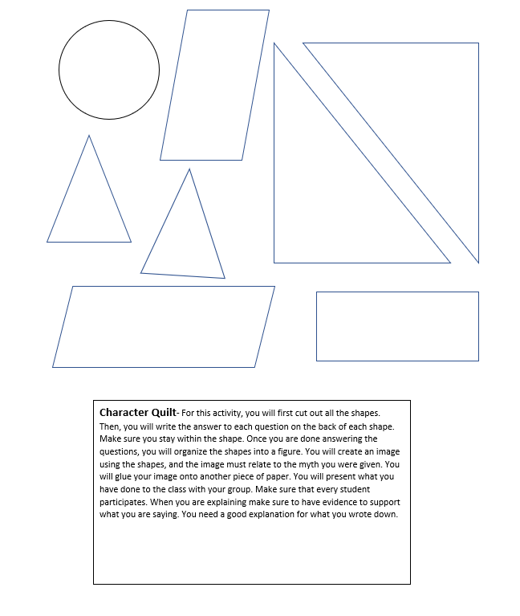
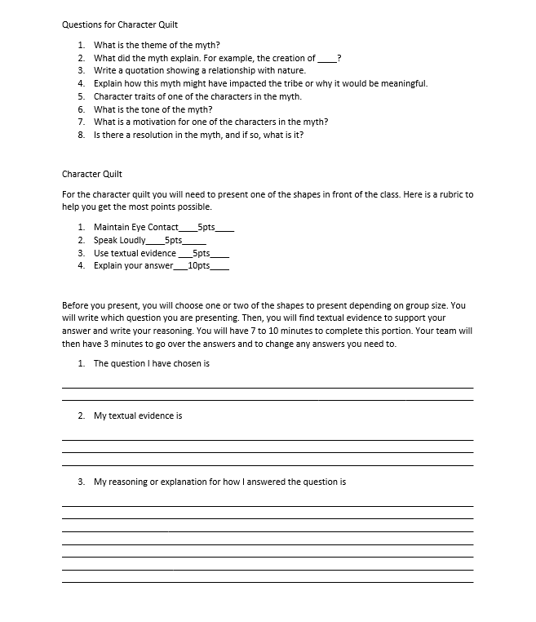

Louisiana Tech University Clinical Lesson Plan Template
Author(s): Lindsay Bollinger, Kennis Jobe, Camden Joiner |  |  | Date Written: November 15, 2022
School: NA |  | Grade: 11 | Subject: English
Lesson Topic: “Tar Baby” Myth Lesson |  | Date Taught: | Time Frame: 50 minutes
Demographic Data
Number of Students: NA |  | Gender: NA | IEP/504: NA
Race/Ethnicity: NA |  |  | Language(s): NA
Lesson Foundations
- Content Knowledge Connections
Assessment Data (formative/summative assessments, observations, etc.) | - NA.  - I’m planning the lesson with the assumption that most of the students can read, but not all at the same level.
Prerequisite Learner Knowledge/Skills | - They need to be able to read and write.  - They need to have critical thinking skills.  I’d like them to have general knowledge about  - Native American Myths  - How to utilize quotations to prove an answer  - Louisiana History
Learner interests, needs, etc., to inform selection of learning outcomes and differentiation | - Louisiana children have a natural interest in our state’s culture, specifically Native American culture and how their myths developed and analysis of those myths.
Describe how this lesson fits within a unit or sequence of lessons | - This is the third lesson of five. It will discuss the tar baby myths, and they will have to analyze these myths.
Personal research on lesson topic | - The Louisiana Anthology collection of Native American myths  - Louisiana History course in graduate school.  - I have studied mythology since childhood.
- Learning Outcomes and Formal Measurable Objectives
Learning Outcome | Measurable Objective
Comprehension | TLW identify the “Tar Baby Myths.”
Application | TLW apply their knowledge of the “Tar Baby Myths” in a diagram.
Analysis | TLW compare and contrast the “Tar Baby Myths” in a written discussion.
- Standards Directly Connected to the Lesson (alphanumeric AND text)
ELA 11 RSL 4. Determine the meaning of words and phrases as they are used in the text, including figurative and connotative meanings; analyze the impact of specific word choices on meaning and tone, including words with multiple meanings or language that is particularly fresh, engaging, or beautiful. (Include Shakespeare as well as other authors.)
ELA 11 LS 1. Demonstrate command of the conventions of Standard English grammar and usage when writing or speaking.
ELA 11 LS 2. Demonstrate command of the conventions of Standard English capitalization, punctuation, and spelling when writing.
- Assessment
- Bellringer (3 minutes, 5 points)
- Notetaking on “Tar Baby Myths” (20 minutes, 5 points)
- “Tar Baby Diagram” (2 minutes, 5 points)
- “Tar Baby” worksheet explanation (20 minutes, 20 points)
- Exit ticket (5 minutes, 5 points)

- Classroom Preparation
Classroom & Class Organization (seating, grouping, etc.) | - The class will work as individuals
Teacher/Student Materials | - Handouts (attached)  - Bellringer  - “Tar Baby” Diagram/Worksheet  - Exit Ticket
Technology Resources | - Computer  - Internet Connection  - Browser  - Powerpoint  - Projector  - Screen  - Speaker
Management Plan (behavior, time, etc.) | - Classroom timer  - Listen and follow directions.  - Raise your hand before speaking or leaving your seat.  - Keep your hands and feet to yourself.  - Respect your classmates and your teacher.

Pedagogy
- Lesson Introduction
- Bellringer: Today we will be reading the story of the “Tar Baby.” What do you think a tar baby is?

- Teaching Strategies
- Integrate technology into the lesson.
- Have students use critical thinking skills.

- Modifications/Accommodations
- Make sure the groups have students with different levels of abilities.

- Learning Activities
- Bellringer.
- Students will take notes while the teacher reads the stories of “Piti Bonhomme Godron,” “The Tar Baby,” and “The Rabbit and the Tar Baby.”
- The teacher will handout the assignment.
- The students will look at the “Tar Baby” Myths Diagram.
- The students will answer the discussion questions on the “Tar Baby”Myths.
- Exit ticket.
- Closure
- Exit ticket.
- Imagine you are writing a text message about today’s lesson to a friend. What would you write?

Required Lesson Plan Reflection (See Pre-Conference form). Required Teaching Reflection (See Post-Conference form).

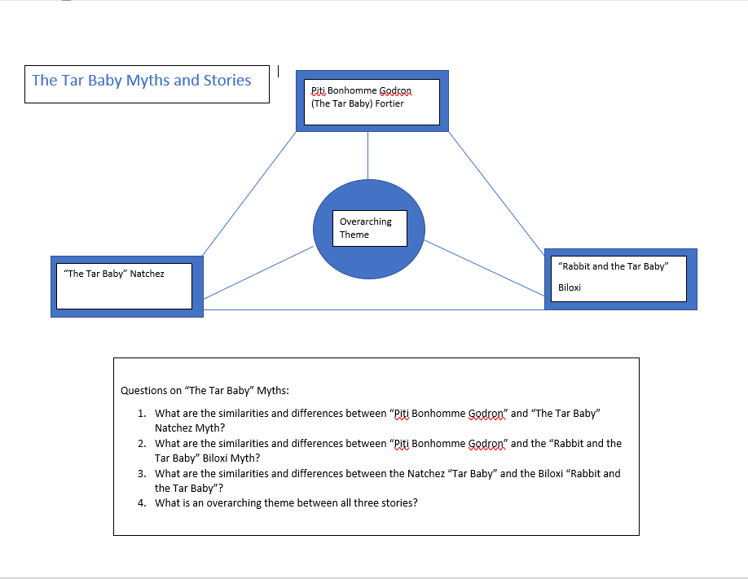

Louisiana Tech University Clinical Lesson Plan Template
Author(s): Lindsay Bollinger, Kennis Jobe, Camden Joiner |  |  | Date Written: November 14, 2022
School: NA |  | Grade: 11 | Subject: English
Lesson Topic: Native American myths of Louisiana |  | Date Taught: December 8, 2022 | Time Frame: 50 minutes
Demographic Data
Number of Students: NA |  | Gender: NA | IEP/504: NA
Race/Ethnicity: Varied |  |  | Language(s): NA
Lesson Foundations
- Content Knowledge Connections
Assessment Data (formative/summative assessments, observations, etc.) | - I’m planning the lesson with the assumption that most of the students can read, but not all at the same level.
Prerequisite Learner Knowledge/Skills | - They need to be able to read and write.  - They need basic research skills.  I’d like them to have general knowledge about  - Louisiana history  - Native American history  - Mythology
Learner interests, needs, etc., to inform selection of learning outcomes and differentiation | - Louisiana students ought to have an understanding of their own state’s literature, including the literature of those who inhabited the area before it became Louisiana.
Describe how this lesson fits within a unit or sequence of lessons | - This is the fourth lesson of five. It will discuss similarities and differences between Native American myths and Greek/Abrahamic ones.
Personal research on lesson topic | - The Louisiana Anthology collection of Native American myths  - Louisiana History course in graduate school.  - I have studied mythology since childhood.
- Learning Outcomes and Formal Measurable Objectives
Learning Outcome | Measurable Objective
Understand | Compare Native American myths to other myths from different cultures.
Analyze | Differentiate cultural values between the Choctaw and Chitimacha peoples as well as the ancient Greeks and Christians/Jews.
Create | Produce a paragraph on ONE of the myths discussed today and what is significant about it.
- Standards Directly Connected to the Lesson (alphanumeric AND text)
ELA 11 RSL 3. Analyze the impact of the author’s choices regarding how to develop and relate elements of a story or drama, including how the author develops character and setting, builds the plot and subplots, creates themes, and develops mood/atmosphere.
ELA 11 RSL 4. Determine the meaning of words and phrases as they are used in the text, including figurative and connotative meanings; analyze the impact of specific word choices on meaning and tone, including words with multiple meanings or language that is particularly fresh, engaging, or beautiful.

ELA 11 SLS 1.b. Work with peers to promote civil, democratic discussions and decision-making, set clear goals and deadlines, and establish individual roles as needed.
ELA 11 LS 1. Demonstrate command of the conventions of Standard English grammar and usage when writing or speaking.
ELA 11 LS 2. Demonstrate command of the conventions of Standard English capitalization, punctuation, and spelling when writing.
- Assessment
- Bellringer (5 minutes, 5 points)
- Overview of Greek/Abrahamic myths (15 minutes, 5 points)
- Notetaking (15 minutes, 15 points)
- Group work (10 minutes, 10 points)
- Exit ticket (5 minutes, 5 points)

- Classroom Preparation
Classroom & Class Organization (seating, grouping, etc.) | - The class will work as individuals.
Teacher/Student Materials | - Handouts (attached)  - Bellringer  - Overview  - Guided note taking  - Group Work  - Exit Ticket
Technology Resources | - Computer  - Internet Connection  - Browser  - Powerpoint  - Projector  - Screen
Management Plan (behavior, time, etc.) | - Classroom timer  - Listen and follow directions.  - Raise your hand before speaking or leaving your seat.  - Keep your hands and feet to yourself.  - Respect your classmates and your teacher.

Pedagogy
- Lesson Introduction
Bellringer: Remember your own myth from Monday. Compare and contrast it with another student’s and write down at least two key differences and one similarity between your stories. (10 minutes, 10 points.)

- Teaching Strategies
- Integrate technology into the lesson.
- Make time for notetaking.
- Students will work in groups and as individuals.

- Modifications/Accommodations
- Make sure the groups have students with different levels of abilities.

- Learning Activities
- Bellringer.
- Brief overview of biblical creation story, fall of man, and tower of Babel, as well as Greek stories of creation and Bellerophon.
- Guided note-taking: answer the questions and fill in the short responses related to the stories covered today.
- Group discussion: How are these other stories similar/different from the Choctaw/Chitimacha stories of the snakes and their poison, the creation, and the gifts of the sky god? What can this tell us about the cultural values of the Choctaw and Chitimacha?
- Exit ticket.
- Closure
- Exit ticket.

Required Lesson Plan Reflection (See Pre-Conference form). Required Teaching Reflection (See Post-Conference form).

Choctaw and Chitimacha Creation Stories

Bellringer: Remember your own myth from Monday. Compare and contrast it with another student’s and write down at least two key differences and one similarity between your stories. (10 minutes, 10 points.)

Guided note taking (15 minutes, 15 points):
What happens to the biblical serpent? _____________________________________ (1 point)
How does the Chitimacha creation story contrast with the Abrahamic and Greek versions?

(5 points)
What happens to Bellerophon and the builders of the Tower of Babel? ____________________________________________________________________________________________________________________________________________________________________________________________________________________________________________________________________________ (2 points)
What does God/the gods use to make people in both the Greek and Abrahamic stories? _________________________ (1 point)
How are animals and their relationships with people portrayed in Greek and Abrahamic myths? How does this differ from their portrayal in Choctaw and Chitimacha myth?

(6 points.)

Group Discussion:
What values can you see reflected in the Greek and Abrahamic stories? What about those in the Choctaw and Chitimacha stories? What can you glean from this lesson about Choctaw and Chitimacha culture?

Discuss in small groups of 3-4 and write down your answers. Turn in your answers at the end of the discussion period.

Exit ticket (5 points):
Consider all the stories we’ve discussed today: “How Snakes Acquired Their Poison”, “Creation”, “The Gifts of the Sky God”, the Biblical Creation Story, the Greek Creation Story, the Fall of Man, the Tower of Babel, and Bellerophon. Which one was your favorite (or least favorite), and why?

Louisiana Tech University Clinical Lesson Plan Template
Author(s): Lindsay Bollinger, Kennis Jobe, Camden Joiner |  |  | Date Written: November 15, 2022
School: NA |  | Grade: 11 | Subject: English
Lesson Topic: Native American Myths Socratic Seminar |  | Date Taught: | Time Frame: 50 minutes
Demographic Data
Number of Students: NA |  | Gender: NA | IEP/504: NA
Race/Ethnicity: NA |  |  | Language(s): NA
Lesson Foundations
- Content Knowledge Connections
Assessment Data (formative/summative assessments, observations, etc.) | - NA.  - I’m planning the lesson with the assumption that most of the students can read, but not all at the same level.
Prerequisite Learner Knowledge/Skills | - They need to be able to read and write.  - They need to have critical thinking skills.  I’d like them to have general knowledge about  - Native American Myths  - How to utilize quotations to prove an answer  - Louisiana History
Learner interests, needs, etc., to inform selection of learning outcomes and differentiation | - Louisiana children have a natural interest in our state’s culture, specifically Native American culture and how their myths developed and analysis of those myths.
Describe how this lesson fits within a unit or sequence of lessons | - This is the fifth lesson of five. It will have the students analyze the myths discussed during this unit, and they will answer questions in paragraph form. They will then have a socratic seminar for these questions.
Personal research on lesson topic | - The Louisiana Anthology collection of Native American myths  - Louisiana History course in graduate school.  - I have studied mythology since childhood.
- Learning Outcomes and Formal Measurable Objectives
Learning Outcome | Measurable Objective
Analysis | TLW analyze the Native American Myths.
Apply | TLW apply their knowledge of Native American myths and answer the Socratic Seminar questions.
Analyze | TLW debate their answers with other students for the Socratic Seminar.
- Standards Directly Connected to the Lesson (alphanumeric AND text)
ELA 11 RSL 3. Analyze the impact of the author’s choices regarding how to develop and relate elements of a story or drama, including how the author develops character and setting, builds the plot and subplots, creates themes, and develops mood/atmosphere.
ELA 11 RSL 4. Determine the meaning of words and phrases as they are used in the text, including figurative and connotative meanings; analyze the impact of specific word choices on meaning and tone, including words with multiple meanings or language that is particularly fresh, engaging, or beautiful. (Include Shakespeare as well as other authors.)
ELA 11 SLS 1.b. Work with peers to promote civil, democratic discussions and decision-making, set clear goals and deadlines, and establish individual roles as needed.
ELA 11 LS 1. Demonstrate command of the conventions of Standard English grammar and usage when writing or speaking.
ELA 11 LS 2. Demonstrate command of the conventions of Standard English capitalization, punctuation, and spelling when writing.
- Assessment
- Bellringer (5 points)
- Notetaking (16 pts)
- Exit ticket (4 pts)

- Classroom Preparation
Classroom & Class Organization (seating, grouping, etc.) | - The class will work as individuals and in groups.
Teacher/Student Materials | - Handouts (attached)  - Socratic Seminar Explanation  - Socratic Seminar Questions
Technology Resources | - Computer  - Internet Connection  - Browser  - Powerpoint  - Projector  - Screen  - Speaker
Management Plan (behavior, time, etc.) | - Classroom timer  - Listen and follow directions.  - Raise your hand before speaking or leaving your seat.  - Keep your hands and feet to yourself.  - Respect your classmates and your teacher.

Pedagogy
- Lesson Introduction
- Bellringer: Write what you think a Socratic Seminar entails.

- Teaching Strategies
- Integrate technology into the lesson.
- Have students work on critical thinking.
- Have students work on speaking skills.
- Have students work in groups.

- Modifications/Accommodations
- Make sure the groups have students with different levels of abilities.

- Learning Activities
- Bellringer (5 minutes, 5 points).
- Socratic Seminar (40 minutes, 16 pts)
- Exit ticket (5 minutes, 4 points).
- Closure
- Exit ticket
- Write 2 things you learned from this Socratic Seminar.
- Write 2 things you do not understand from the Socratic Seminar.

Required Lesson Plan Reflection (See Pre-Conference form). Required Teaching Reflection (See Post-Conference form).

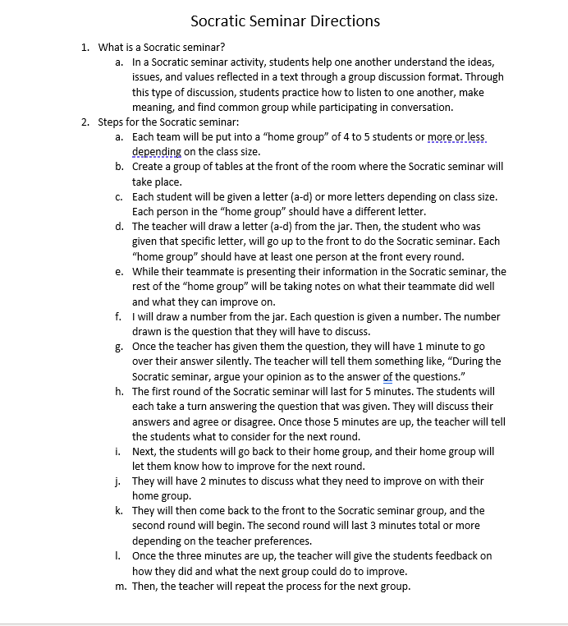
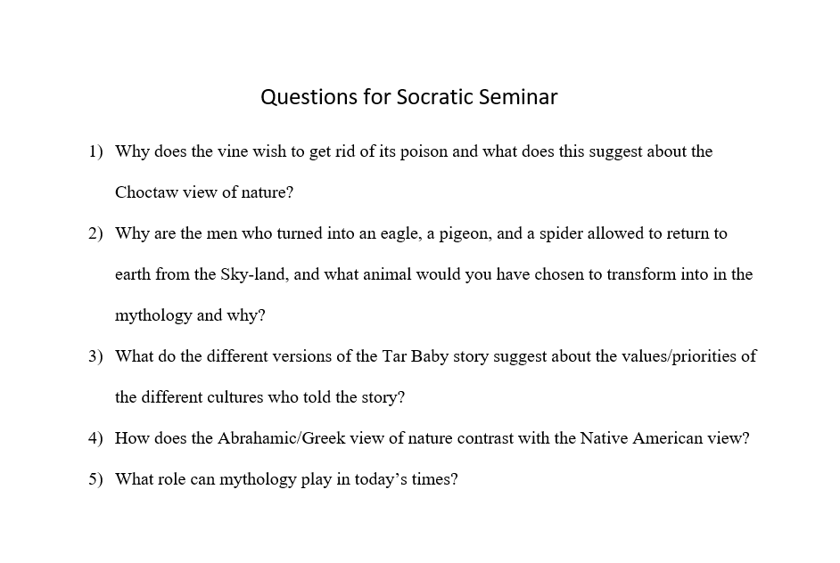

dd

